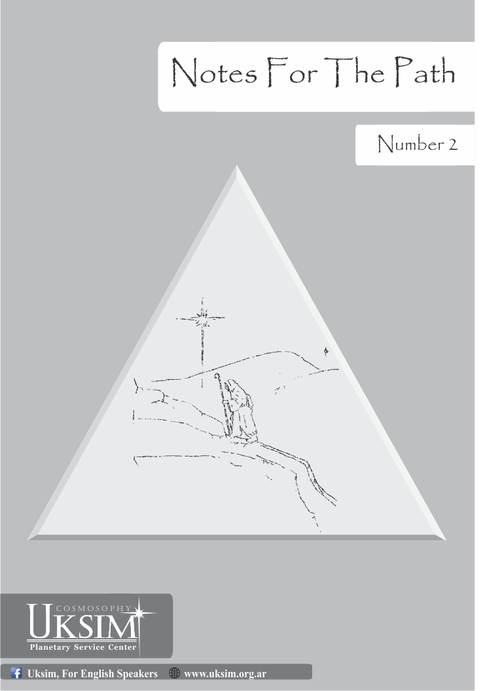

On one occasion, a being sought to quiet down, and thus come into contact with deeper levels of existence. This was carried out, at times when the person had to concretize some matters, necessary to solve certain tasks committed to the Evolutionary Plan. As an answer to the search, to the attempt of opening and alignment, an image, perceived by internal channels, came to its assistance:

   A plain, of short and healthy herbs, which seemed to be a sunrise.
Some birds flew in that place, but without flying away,
as participants of one of the levels of energy consciousness
that manifested itself there.
The sun, which occupied the bottom line of that vision, was different.
That sun had already gone through certain processes that,
in our current time-calendar, have not yet been concretized.
The image, lacking of sensationalism, emanated a peace
that permeated everything.

That being, receiver of that image, knew how to begin at that precise moment the task that was waiting for. The person also understood in a different way the rhythms that the task should be carried out.

At every opportunity that human beings could open themselves to the impulses coming from their inner being, will be present, and at its disposal, the guiding energy. It will be able to manifest itself in the most convenient way to the Plan, in obvious or internal forms, protected from the greatest amount of interference. The being who lived that experience knew that the benefits of that experience were not limited to the mere personal use of it I knew that the entire internal working group, of which the being was part of, had been touched by that harmonizing dynamic energy.

That image, placed at the disposal of that group, through that channel, impelled and prepared the consciousness for a different existence. An existence where the patterns of life were instruments of the Hierarchy.

Without hurries or emotional outbursts, the task entrusted to us will become a reality. When a task is entrusted to a group of beings by the Unique Energy, rhythms and times are foreseen for its execution and tuning within certain limits.

In some cases, the task itself consists of the effort to carry out what has been entrusted, without deviating the focus of the goal and purpose.

The final purpose is common to all beings in evolution, but not so the way of the path to it is transited.

The creative sound that is their own resounds inside all beings. That note, combined with the agents of cosmic life, is a perpetual activator in the evolution of consciousness; it is, together with the primordial nuclei, the vehicle that will allow the return to the source. It keeps in itself the codes of access to origin.

             

The firm decision to accept what is indicated to you is necessary for your development and evolution, but you must continually be aware of the concrete concept of the permanent evolution of the principles. While it is necessary, for the implementation of the Evolutionary Plan, your decision to serve and obey, this would not be useful if you were not able to accept the changes and transformations that, many times, will give a radical turn to the structures that you use, in a certain period of formation or transition. Remember, that one of the greatest impediments of the civilization that you conform -on the surface of this planet - is the lack of lucidity, with respect to the timely abandonment of certain schemes, out of date and devoid of protection by the Hierarchy.

As you subtilize your mechanism of reception, and you become impartial elements of capture and transit of energy, it will be a lot easier for you to determine the necessary changes to each circumstance. Many times, those changes, in appearance, will only serve you -as a prelude and preparation- so that the same ones can then be implanted in a wider spectrum; embracing their development, sets of beings that are assembled under the law of affinity. Many times, these changes and adjustments will take place in unnoticeable forms and in subtle ways, to such an extent that your outer consciousness will be the last receiving particle of them; as perception, it can resemble a soft wave that comes exhaling at the edge of a pond. At other times, these modifications may reach the concrete consciousness in a way that is vertiginous…overwhelming, its implantation and capitation will be simultaneous. It will be the strong ray falling with all its strength, modifying everything, releasing with its igneous current, purifying and transforming in an unequivocal way. After its action everything will have been changed.

Be careful of the emotional relationship with the elements placed at your disposal to your way back. The nature of these elements is varied, as are the levels where they are implanted for use and service. Remember that their existence is only justified, in relation to the real effectiveness, within certain cycles and rhythms, and which, outside of them, can be transformed into discarded material, potential obstructs of the levels where they should have served.

Regarding genetic condition you are still capable of crystallizing. Be attentive, this will greatly facilitate the correlation that must exist between the attitude of the suit, and the impulses that the inner being emanates to qualify the corresponding tuning. In this way, the whole mechanism that you make up will be able to adapt with less interference and shocks to certain facts and issues impossible to foresee, characteristic of the circumstances corresponding to an end of cycle.

             

Like a mountain spring, with its offering on time... like a flower that, in sublime art, bleeds cocoon and womb, and neither muscle nor word are tools of its force. Thus, the cosmic destiny of man is revealed to us, sacred conspiracy of origin and return.
            
            

If you have decided to give your boat's course to the supreme helmsman, why do you fear the voracious reef?
If you have prepared to relieve your baggage, why now do you anxiously seek the remembrance of what you have seen in the past?
Look at the horizon; according to the consciousness reached by the observer, it represents the unattainable, or the starting point in the deep search for being.
Look at yourself on the surface of the rested lake, you may choose to stop at that ephemeral image returned to your senses, or dive into total acceptance and become, integrated, consciousness-mirror of the One Life.

            

The immaterial particles possess, by way of lineage, the key that contains the secret of a level of existence even deeper than that of immateriality itself.



To impel humanity and to collaborate with its restitution to the source is, in synthesis, the path of energy offered in these times.

            

The truth is like a mountain, everyone must access it by going up the hillside more in accordance with their limitations. The important thing is not to boast about reaching that illusion called the summit, but rather, in advancing towards it, to humbly raise awareness of our smallness and ignorance.

            

When the personality polarizes its efforts in the search for the truth, it resembles the persevering salmon, which going up the adverse river, when it reaches its goal, it only remains for it to surrender everything, and dying, to be born to another state of consciousness. 

            

Humanity, as a whole, is undergoing the necessary transition for the adjustments that will inevitably happen.

High Hierarchies accompany the Planetary Logos in this transmutation that he will have to perform. Beings and entities of the high spheres of the Universal Consciousness, mirrors and logos of different evolutionary degrees, as well as devic entities, have centered their actions in this, the awakening of the planet Earth.

The incorporation of the Earth to the Intergalactic Confederation, allows one more turn in ascending sense, inside the evolutionary spiral, to the whole solar system, reason why a great resonance is produced in all the galaxy.

The task of the great consciousnesses that compose the processes of the current cycle must be accompanied by the polarization of consciousness, on the part of the emancipate convened, in the planes that are above the causal level; in other words, outside of the density and the play of forces of the three-dimensional level.

It is with the development of the vortices of the Cosmo-Sono-Medular field, or right conscious, that the self convened may be located within the task, in the right attitude. It is precisely with the polarization of the being in the higher levels -in this case the awakening to the intuitive level - that each being open to these realities and achieved the necessary alignment- becomes as an acupuncture needle stuck in a sick body. Thus, in this way, the healing energy also resolves and concretizes one of its ways of reaching, through a certain profile, the attacked planetary body.

With the embracing of broader states of consciousness and the commencing of service, it is that those self-convened can fulfil that for which they incarnated.

For this to happen is necessary a certain predisposition. To leave the comfort and crystallization on certain entrenched forms, what is supposed to be aligned to a spiritual path or inner quest. The different forms in which the law of inertia can be manifested, find, underhandedly, in many beings of goodwill, the adequate material for its implantation. This is how active nucleus is maintained that should no longer interfere with the performance of the beings that are needed in the larger and more deprived areas of the task.

When the guidelines for this new stage were received, where certain tasks that corresponded to us would be expanded and/ or modified, it was clearly noted that those with which we shared these matters- within this cycle - were going through profound changes, and that these were the product of the same process, which projected, assumed as needed by the Plan, a range of interactions.

As our donation and giving deepens, we become permeable to the process of the energies. Our three-dimensional bodies are beginning to show signs of supplanting the impulses of the reaction, by clear samples of response.

It is necessary to take into account with greater clarity, that while certain conflicting nuclei (which are part of the circling through which some commitment is realized), they are not yet completely dissolved, they should no longer at this stage, manage and interfere our d
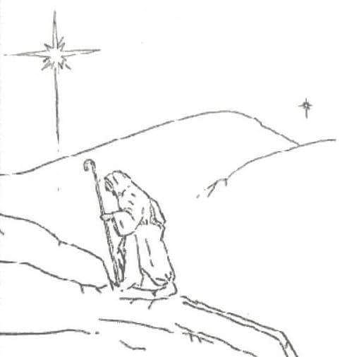

evelopment. The fact that they are not managed by certain processes does not mean that there is no continuous transmutation, in terms of the activity of those conflictive nuclei, which with greater or lesser intensity, will continue to accompany these suits, whose constitutive material comes from the three plans where the conflict is established on a planetary level.

The renewal of the commitment to the Evolutionary Plan is fundamental for the development of beings that begin to awaken and take their place in the planetary service.

Instructors and energies of immaterial levels bring to humanity renewed impulses. Impulses that come from spheres where superlative laws govern this current cycle. These instructors and these energies are of fundamental importance for the aforementioned relationship with planetary service.

Writings like this are inspired to collaborate with a particular area of service.

When a certain nucleus is activated, when a vortex begins to implant, when the pulsation of non-concrete planes is manifested, there is an inevitable reaction from the opposing forces. These forces focus their attack by using as a channel dark points that we still keep alive. Identifying and collaborating with the removal of these conflictive points is an important part of our service; being the surrender and donation of oneself, the adequate tool, so that consciences and energies suitable for the treatment of these points can be used to carry out tasks of transmutation, re-harmonization and healing, which are beyond our limits .

From this it can be inferred that the human being in his present state should not face certain processes, which would only lead to greater commitments and karmic imbalances. They can only operate in tasks of rearrangement of a level, in real form, laws and consciences coming from planes that are free of the conflictive action to heal.

Certain schemes from the previous cycle must be released in order to predispose to contact with new spheres of its evolutionary process. Where necessary and those schemes and formulas, should be taken as steps, alternative deposit for a certain period of time, resulting from our successive conscientizations. When taken advantage of, this stairs-steps having the appropriate elements, for the incentive would allow the preparation and participation with the reality in an increasingly subtle and comprehensive way, gradually taking the consciousness to levels, that we will call levels of return.

In order to continue the ascending transit through these levels of return, with the necessary adjustments for this cycle, it is necessary to re-dimension and try to understand the exact indications of an energetic accurate geometry for these moments.

SYNTHESIS - ATTENTION – SILENCE

The words, the forms, the nuances, are nothing more than different complexion, with which we have been asked continuously, we have been deeply encouraged to achieve, sensitively, integration. Humanity of the surface of the planet failed to integrate into the planetary essence, fact that results in dislocation, disconnection with its cosmic origin. Under the format of a task, a certain percentage of humanity corresponds to collaborate, so that the current disconnection is overcome. It is through the geometric-energy triangulation of synthesis, attention and silence, that this remnant is refined as an instrument for this achievement.

            

The deep and true changes, only have to be implemented through those beings who see feasible to undertake the impossible. Only a real distance from the analytical, will allow the necessary divestment, to implement what will really regenerate the outdated. That allows life to demonstrate again that which is its irrefutable proof: the overcoming of each of its stages of manifestation. Is it not the case that life, with its precise and timely dynamization at each stage, shows us how it is integrated in superlative forms each time?

Only those beings who are already susceptible receivers of the implicit impulses in each cycle can act according to these necessary and unrepeatable changes. Beings capable of thinking of the impossible, as a reality that urgently needs to be expressed at each corresponding level. Beings that begin to discover the impossible, also pulsating in themselves; making them true pioneers. Pioneers who will be equipped with inexhaustible energy; energy that will flood them, with gentle but unstoppable force of the rising tide, which will always be at their disposal, if it is used to bathe the corresponding beaches.

             

You will always find what to aim for in your path, beware of repairing, primarily the essence; when aiming indiscriminately; it is possible that you are, for that reason, losing a precious annotation, suffocated in your lack of synthesis.

             

Whoever has walked its steps towards the light, must emulate the diver, who decided to advance to the encounter of his greatest pearl; taking care not to confuse the liquid medium that he must leave behind, with the very purpose of his search. Taking care not to identify himself with the bodies of water that he must transcend, and which will always try to separate him from that which, veiled, has always belonged to him, immersed in the depths of what he has been looking for – that, what is truly real.


Carefully, as one who transports a valuable but fragile treasure, the beings surrendered to the return must attend the Evolutionary Plan in this transition; bearing in mind that the maintenance of calmness is asked of them as a primordial condition of awakened beings.

No one can, in a mad race, transport -or do what must be done- in concomitant rhythms to encompassing cycles and guiding impulses.



The search?...is the path that has been left behind and the one that is ahead... is your attitude, adjusted skillfully, to the dynamic impulses that each time you will have to receive more purely, to finally lose the imaginary limits of the path, merging with the unity.



It is known with certainty that one of the tasks to be carried out by certain groups that manifest the Evolutionary Plan is to serve as referents to some beings who are devoted to the search for the truth and transcendence of the patterns in humanity that are still in force on the surface of this planet. For this it is necessary, that a group donated as an evolutionary instrument, has transcended certain aspects and incorporated patterns of conduct, according to what should be manifested as an archetype.

Some beings, with strong pressures from material levels, will reach these groups with almost totally exhausted forces. In the great turbulence unleashed at the end of this cycle beings who are to be led by the Hierarchy and by their inner selves into contact with the inner groups that these groups must signify. For that, self-forgetfulness, and unconditional self-giving, must emerge in the pillar-components of these groups, dispensers of harmony and protection.

It’s necessary a full awareness of what the Hierarchy is demanding of us.
Certain tasks require a greater flow of lucidity. This lucidity, to which we refer, is the resulting from unconditional alignment.

It is not possible to provide that which is not yet incorporated. It would be like the invitation to a banquet, with nothing to put on the boards.

The lucidity referred to, is also that which will allow -with love as a vehicle or- the implantation of a certain energy, which will dynamically adapt the circumstances and will put the situations in the most appropriate coordinates for the following assemblages that the Plan may require.

            

-- Lord, some time ago you had told me that the corresponding attitude and surrender would make me a torch. Well... I'm not sure I could have served or enlightened anyone.
-- I have never told you that among many the light has one addressee.
-- But... then, Lord, I have not been able to fulfill that which you revealed to me.
-- My son... it is this Universe-Earth that you have to enlighten; it is this obscured materiality that prays for precious drops of light.
Tell me... do you feel in you the unquenchable flame?
--Lord, you know best that in me the sacred fire has awakened, and I give myself to him in purification.
For then, you have been accomplishing your task; for it is impossible, that such a bonfire should not have happened. I was able, in such a long and cold night, to provide shelter and refuge. Like a real bonfire, you could do nothing, burning, seeing beyond your perimeter. That is why your light, my son, has had the necessary reaches to the One before whom we bow to.

            

Your faith in us would be of little use if you do not trust in your decision to follow your path in an ascending manner. In truth, it would be of little use.
All the devotion that you put before our presence must exist, as a reflection, in the constant attitude that you must maintain in the levels where you now have to manifest yourselves. It would be useless to raise your arms in praise towards the heights, if in that march you do not make the right step, and you drag your feet as the vanquished does.
You are of the spirit, do not forget it, always remember to whom you have given yourselves, to whom you belong. You have been told that "He will come like a thief in the night".
There is no thief who can rob the Father; whoever entirely gives itself will allow the Father to be in him without interference.
If there is something, among other glimpses, that your current state of consciousness allows you to see more clearly. It is the lack of decision to take certain steps that are fundamental for you and the Evolutionary Plan.
Beware of the discomfort and imbalance that the perception of this delay can cause; do not project it or justify it in the criticism of other companions along the way, or in the hollow and corrosive speculation of the Evolutionary Plan comparison.
To glimpse the path no longer serves you; you must, at this point, be the living map of it.
When night falls, you should have served as a guide and reference for those who read your footprints. It is up to you alone to accomplish certain stages of the task.

             

That night was serene. It had been a few hours since the person, whose existence is devoted to the Plan Evolutionary, rested without interruption. In a moment, that being noticed that he was impelled to interrupt his sleep; he waited lying down for a few minutes, lapse in which a clear impulse was manifested as un indication. This indication seemed to include, subjectively, the continuation of some writings channeled through this being as an assumed task related to the Evolutionary Plan. Heading for the place where he used to write, he arranged the atmosphere in the way he was accustomed to, and accommodated himself by predisposing himself to a quietening.

Within a few minutes, the stillness to which this person had surrendered began to undergo a transformation that led to a deep state of prayer.

After some time, he began to reach the concrete consciousness, the possibility of being able to perceive the presence of a great source of energy; the same, was present, intervening in direct form, in everything that was happening with him.

Like closing a circuit, and at the same time a stage within what was happening, that person pronounced a few times, and in the rhythms internally indicated to him, the name that that presence, representative of the Unique Energy, revealed as a necessary instrument for that experience.

As we know, according to the demands that a task requires, a consciousness of high evolutionary level can use different impulses that are transferred to the corresponding plane, in the energy that we call name.

When the presence of this great acting consciousness was withdrawn from the level of concrete capture of this being, the original state of stillness was revealed as a remnant of what happened.

The experience described, although it has several profiles of use such as learning and training, revealed, from the first moments of completion, one in particular:

The great need to move forward without preconceptions or previous judgments, even those which, apparently, might seem favorable to the Evolutionary Plan.

The prevailing need to strictly obey, what is revealed and indicated to us, without additives of the Evolutionary Plan from the personality, or at least with the lowest possible interference rate.

The being, who had to live the experience described here, could not avoid thinking. preparing the environment where he used to write, that this would be one more session of transcription to paper, of certain impulses. He had come out of the room where he rested, with the only and precise indication, change of environment, and to be predisposed to a quietness. It was the personality, the one who thought to read between the lines, that a writing session would follow, as in this way usually happened with that being in service.

If the crystallization had been greater, this experience might not have happened, or in any case, have been interfered with.

Certain flexibility, achieved by this being in learning, is what allowed him not to spoil what was being necessary to experiment. He saw clearly where certain adjustments should be made and should have taken into account. From now on, what this experience will bring to him as an enriching learning.

             

You know that, in a certain state of consciousness, you are a note. A sublime note, which is expected to resonate and to be performed in an ever-increasing context of the sacred symphony of the spheres.

The outburst of that sublime performance has never been heard by you. But not because of that, his rhythm stops resounding sweetness within you.

In the sound and light, the great symphony reflects the incorporation of the chords, which are coupled in each renewed and unrepeatable octave.

Your integration is expected.
Let yourselves be guided by the Great Conductor; trusted in his precise gesture, which starts from the deepest cores of the Unique Life, the perfect manifestation of the work.

            

Precise in its manifestation, and unrepeatable, administrator and continuator of the impulses from its origin, the great Plan of manifestation of Universal Life becomes notoriously present, once again, on this planet of transition.

In compliance with the Law, myriads of beings of high evolutionary level - coming from diverse cosmos regions, descend in sacrifice, to the densest levels of manifestation of an unbalanced planet, of a collapsing planet, of a planet that can only hope for redemption as an option.

There are men, who beginning to glimpse certain issues, believe that it would be convenient to take into account changing the course of events; so, by doing so all the current imbalance could be reversed. Others, succeeding in manifesting a greater momentum, not only believe that everything must be changed, but rather, in an attitude of direct confrontation with the growing chaos, they put themselves at the service of schemes and movements, which claim to have the formula - and tools - to operate the much-needed change and save this planet. It can be said that the two positions described here are relatively useful, and always circumscribed, at a certain level of consciousness and evolution.

Previously in the text above we made reference to the intervention in this world of extraterrestrial beings of high evolution, that in a state of extreme attention, assist this humanity that walks on the edge of evolutionary failure. Beings that in joined and precise action also conform the operations in which they interven with the intraterrestrial and intraoceanic civilizations present in this Earth Universe. The true collaboration for the present terrestrial process - on the part of the surface humanity of this can only manifest through the presence and service of the self-called. In this planetary rescue process only the self-convened beings who inhabitants the surface of the planet, could provide bonds of service. In regard to these so-called "service bonds", it is where great processes arise and are activated, centered on the action of involutive forces, which have achieved maintain, both inertia and unconsciousness, a number of potential Evolutive Plan Servers, destined to assume tasks in a lucid and conscious way.

Nothing that has been said so far is new to those who in a certain way have achieved to direct their steps towards planetary service; of those who have been able to detach from rigid structures, destined to impede the contact of terrestrial humanity, with the impulses poured -from the very core of life- for its evolution.
From the Central Government of the Universe waves have emanated, the appropriate impulses, the orders. The Earth is to be taken to the next evolutionary step.

Everything has been predisposed in response to the supreme transmuting impulse. The tension and attention of the higher consciousness in charge of the rescue and evacuation operation, allows the Unique Energy to be with all the necessary conditions, so that, the perfect universal order, creates the corresponding readjustments.

Like a weak, aged and wormy fruit tree, which can still give the Creator some flowers with love and gratitude, some fruit, humanity gives its best sap in the presence of the self-called. Born of his own cosmic womb; led by light, and protected as a filament destined to radiate it. Testimony of the Christ’s Energy, consequence of love, desired objective of the forces of chaos, son of service. The auto- convened is a fundamental anastomosis, in the descending line of the irradiation and emanation, directed for the rearrangement of this Universe-Earth. Without its presence the whole Plan would have to be rethought.

We could say that, in particular, there is one, that it would seem the very refinement and sophisticated of the mechanisms at the service of evolutionary retreat and retrocession. Its action and setting in is simple but effective. Basically, it consists of using impure nuclei without dissolving, to achieve the confrontation, among themselves, of those self-summoned who still do not identify their complicity with them mechanisms. In ways, at times very evident, it is possible to identify groups where these beings converge, or circumstances, in which they should be related, where confrontations and games of force dissolve and weaken a great part of the energy that the self summoned should channel through its presence as a planetary being on the surface of the planet. The lack of a deep understanding, of how to express, at each stage, the self-convocation relationship between beings thus compromised, is common to find and observe.

We often see how self-convened beings, aligned to different nuclei -different profiles of the unique task-, pass through stages as prisoners of ego processes, the arrogance and undervaluation of other brothers, and even a very subtle but perceptible variant of demagogy. It is common to see them competing, exhibiting the truth, as a patrimony assigned to them exclusively by the Hierarchy. Much of the potential of these summoned beings disappears, in those processes inherent to the dense clothing that will affect them in this transit through matter. Only those among them who, by means of aspiration and surrender, could escape such convincing illusions of ethereal-physical, emotional and mental extraction, can make a major advance in their service.
Only those among them who achieved the escapism of such compelling illusions of etheric-physical, emotional and mental extraction can make a major advance in their service.

Love comes to our planet from the deepest core of the Unique Life; infinite vehicles reflect his face, and countless presences his warmth; nothing would prevent him from ruling, but he puts his yoke on no one divine, its burden relieving, if not from the surrender to the Unique and the will to integrate it. but no one imposes his divine yoke, his weights, that relieves, if not from surrender to the Unique and the will to integrate it.

The self-called is in itself, medullary, is the essence of the Law of Love and permission for one of its forms of manifestation among the heart of this humanity. It is urgent that these beings reflect this reality, in each step taken in the its provision of aid and service.

They are still awaited, and it is still time to do what justifies their presence in this transition. Although it is Certainly, if the case arises, other consciousnesses could realize what would correspond to them, the laws of the world love and cosmic order, will follow, as at each corresponding stage, providing the most sublime impulses for awakening.

            
            

No... You will not be able to say that you had not been warned; No... You will not be able; Neither will you be able try to give your apology, and argue that your decision to serve the Plan makes you rush and overlook some things, and run over others.
No...There is no time for hypocrisy.
There is no time for disobedience.
There is no time for detours and vain illusions.
The quality of this current process depends to a great extent on the response of the beings who summoned themselves on the surface of this planet, in this transition.
Many of you asked for the fire of action, and now, the Law of Service puts on the coals of that action, you complain about the burns.

            

Truly we say to you, that for every wound you shall have seven balsams, that for every wound you shall have the blessing of the heavens, and for each tear shed by the action of opposing forces, a spring of life... do not doubt the face of the Nameless One will be revealed to you at the exact hour, and the joy of the hour will resound in you.

All your search, when sincere, will be satisfied and fulfilled to the highest degree. All Love acting in this universe will then be revealed to you, and you will understand, why, He is the driving force of life. The glory of the Heavenly Father, will be without veils to soften its power, and purified men will live the Law.

Purification... if there are terms that you must take into account, here is the most significant at this time that you live; in silence accept its action and in silence thank the purification law. In silence also, you will be washed and released. Accept it with gratitude, accept it with humility, accept it with sincerity, accept it because it is exactly proportional to your past and present actions. Accept it because it is the Law, and whoever accept the Laws accept the Father. Under this ray everything will be ordered and harmonized; accompany the ray, and not wait in the inertia for the twists and downs of life, fluid in it, and do not tie yourselves to the structures that it will knock down.

Do not waste time filling coffers; where you are going you must arrive naked; do not rush to pack; In the abode that awaits you is that which has always belonged to you, and which the Father keeps for you.

Overcome the impure scabies that prevent you from being free; see yourselves in your smallness, and then you will discover your greatness; know you sparks to understand that you are bonfires; discover yourself as a small drop, to share and embrace the immense sea of the Cosmos; and once and for all understand that your greatness only is in service; that your fire is only , if it overcomes darkness and illuminates the dark impoverished; and that you consist the immense sea, only if you quench the thirsty.

Then, my children, you will know how to interpret my Father's pulse, and you will have overcome the greatest obstacle, your own darkness.

LIGHT and LOVE

(Impulse emitted by a Being; whose existence is polarized in immaterial levels)

A law is first and foremost a state of consciousness. For the beings who begin to transcend certain Evolutionary state, a Law reveals itself as an entity. For the current state of this planet, are becoming present laws that, in interaction, prepare the redeemable beings in this period of transition, and incorporate the possibility of descent, until the denser plans of the etheric physical, of the new patterns through which the archetype will have to be embodied.
A Spiritual Center is not the result of a human choice, is the capture and posterior obedience of the implementation in the concretized plans, an element of the Planetary Service provided by the Plan, to complement a network composed of different levels of consciousness.
Uksim is the reception of an impulse, is emission-capture, is a resonance that captured and accepted, becomes revealed as a form of polarization toward the internal worlds.

Groups of beings that make its preparation in relation to certain areas of the Evolutionary Plan, will make contact with the UKSIM state of consciousness and in this way to channel their service by broadening the spectrum of their tasks.
The beings who begin to awaken, are called to take its place.
In some cases, UKSIM SYMBOLIZES that place.

Peace

Sierra of Heaven Field
Provincial Route 17 - Km. 7 - Road to ongamira - Quebrada de la Luna - (16 Km Charbonier. of Capilla del Monte)
TEL: (03548) 15- 564-874

C. C. NO. 19 - CP 5184 - Capilla del Monte - Cordoba - Argentina uksim@uksim.org.ar

Www. uksim.org.ar Uksim, Center of Planetary Service

Uksim has a Special Account in the Banco Nación Argentina, enabled to receive donations. The number is 181100427 - 6 Branch Code 1300, Córdoba, Argentina.

CBU 0110181840018110042762
For deposits from abroad, at the area cod and account number, the SWIFT code corresponding to Banco Nación Cordoba: NACNARBACOR 0110181840018110042762
7/15/2015

